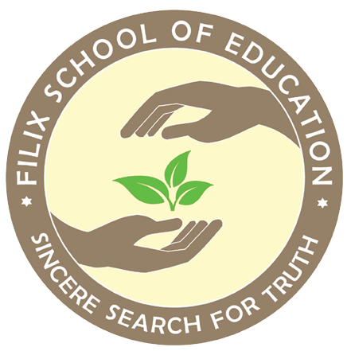

Filix School of Education
Book List [2025-26]
Grade I

Subject | Name of Books
English | - Mridang 1[NCERT]  - Sparkles 1 Nanritam [Subject Enrichment]  - The Cherry Tree by Ruskin Bond Puffin[Subject Enrichment]  - The Magic Finger by Roald Dahl Puffin [Subject Enrichment]  - My Merry Book of Cursive Writing B Kangaroo Books [Subject Enrichment]
Mathematics | - Joyful Mathematics I [NCERT]  - Journey Through Numbers 1A and 1B Nanritam [Subject Enrichment]
Bengali [Second Language] | - Sahaj Path 1 Chhaya Prakashani  2. Aamra Pori Aamra Likhi 1 Shishu Sahitya Sansad  3. Aamar Haater Lekha Srijan Publications
Hindi [Second Language] | - Sarangi [NCERT]  - The Learning Bridge Hindi Pathmala 1 Bhag 1 Onelern [Subject Enrichment]  - Meri Sulekh Mala 1 Golden Circle [Subject Enrichment]
Computer Science | - Code to AI 1 Avartan

